"""
Collections:

Multiple Choice:

1. Examples of linear collections are:
a. Sets and trees
b. Lists and stacks

b. Lists and stacks

2. Examples of unordered collections are:
a. Queues and lists
b. Sets and dictionaries

b. Sets and dictionaries

3. A hierarchical collection can represent a:
a. Line of customers at a bank
b. File directory system

b. File directory system

4. The == operation for two lists must:
a. Compare pairs of items at each position for equality
b. Merely verify that each item in one list is also in the other list

a. Compare pairs of items at each position for equality

5. The map function creates a sequence of the:
a. Items in a given collection that pass a Boolean test
b. Results of applying a function to the items in a given collection

b. Results of applying a function to the items in a given collection

Searching, Sorting and Complexity:

Multiple Choice:

1. Timing an algorithm with different problem sizes:
a. Can give you a general idea of the algorithm's run-time behavior
b. Can give you an idea of the algorithm's run-time behavior on a
particular hardware platform and a particular software platform

b. particular hardware platform and a particular software platform

2. Counting instructions:
a. Provide the same data on different hardware and software platforms
b. Can demonstrate the impracticality of exponential algorithms
with large problem sizes

a. Provide the same data on different hardware and software platforms

3. The expressions O(n), O(n^2), and O(k^n) are, respectively:
a. Exponential, linear, and quadratic
b. Linear, quadratic, and exponential
c. Logarithmic, linear and quadratic

b. Linear, quadratic, and exponential

4. A binary search assumes that the data are:
a. Arranged in no particular order
b. Sorted

b. Sorted

5. A selection sort makes at most: ?????????????
a. n^2 exchanges of data items
b. n exchanges of data items

b. n exchanges of data items

6. The best-case behavior of insertion sort and modified bubble sort is:
a. Linear
b. Quadratic
c. Exponential

a. Linear = best (avg = Quad)

7. An example of an algorithm whose best-case, average-case, and worst-case
behaviors are the same is:
a. Sequential search
b. Selection sort
c. Quicksort

b. Selection sort
https://www2.cs.duke.edu/courses/fall01/cps100/notes/sorting_cheat.txt
8. Generally speaking, it is better to:
a. Tweak an algorithm to shave a few seconds of running time
b. Choose an algorithm with the lowest order of computational complexity

b. Choose an algorithm with the lowest order of computational complexity

9. The recursive Fibonacci function makes approximately:
a. n^2 recursive calls for problems of a large size n
b. 2^n recursive calls for problems of a large size n

int Fibonacci(int n)
{
if (n <= 1)
return n;
else
return Fibonacci(n - 1) + Fibonacci(n - 2);
}

b. 2^n recursive calls for problems of a large size n

Linked Structures:

Multiple Choice:

1. This linked structure contains links running both directions:
a. Singly linked list
b. Doubly linked list

b. Doubly linked list

2. This link allows the user to access the last item directly:
a. Empty link
b. Head link
c. Tail link

c. Tail link

3. The basic unit of representation in a linked structure:
a. Node
b. Container
c. Collection

a. Node

4. We do this operation to visit each node:
a. Stepping
b. Traversal

b. Traversal

5. An empty node pointer is represented as:
a. None
b. Empty
c. Nought

a. None

6. This points to the node following the current node:
a. probe.data
b. probe.next
c. probe.head

b. probe.next

7. Doubly linked nodes usually have all of these attributes with the
exception of:
a. next
b. prev
c. data
d. index

d. index

8. Nodes in a singly linked structure contain Data and:
a. next
b. prev
c. cell

a. next

9. A doubly linked structure allows the programmer to move:
a. To the next node or the previous node from a given node
b. To the next node only from a given node

a. To the next node or the previous node from a given node

Stacks

Multiple Choice

1. An example of a stack is:
a. Customers waiting in a checkout line
b. A deck of playing cards
c. A file directory system
d. A line of cars at a tollbooth
e. Laundry in a hamper

b. A deck of playing cards
e. Laundry in a hamper ?????????

2. The operations that modify a stack are called:
a. Add and remove
b. Push and pop

b. Push and pop

3. Stacks are also known as:
a. First-in first-out data structures
b. Last-in first-out data structures

b. Last-in first-out data structures

Queues

Multiple Choice

1. An example of a queue is:
a. Customers waiting in a checkout line
b. A deck of playing cards
c. A file directory system

a. Customers waiting in a checkout line

2. The operations that modify a queue are:
a. Add and remove
b. Push and pop

b. Push and pop

3. Queues are also known as:
a. First-in first-out data structures
b. Last-in first-out data structures

a. First-in first-out data structures

Trees

Multiple Choice

1. The distinguished node at the beginning or the top of a tree is called:
a. Head node
b. Root node
c. Leaf node

b. Root node

2. A node without children is called a:
a. Single node
b. Leaf node

b. Leaf node

3. Each level k in a full binary tree contains:
a. 2k nodes
b. 2^k + 1 nodes
c. 2^k - 1 nodes

b. 2^k + 1 nodes

4. Assume that data are inserted into a binary search tree in the order
DBACFEG. Preorder traversal would return these data in the order:
a. DBACFEG
b. ABCDEFG

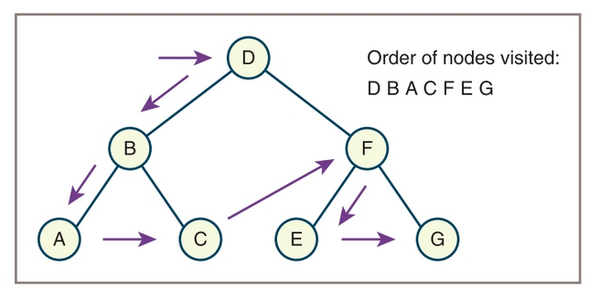

a. DBACFEG

5. Assume that data are inserted into a binary search tree in the order
DBACFEG. Inorder traversal would return these data in the order:
a. DBACFEG
b. ABCDEFG

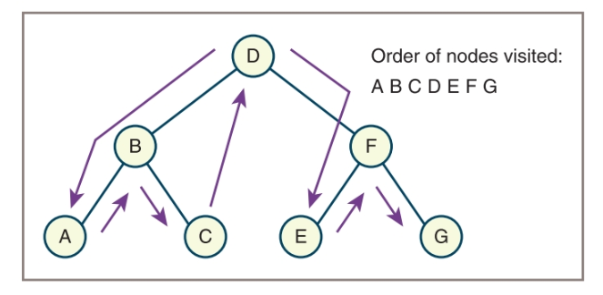

b. ABCDEFG

Regular Expressions:

Multiple Choice

1. To use the regular expression module you have to import:
a. re
b. regex
c. regularexpressions

a. re

2. In order to look at every regex match as a list of iterable objects you use:
a. re.search()
b. re.finditer()
c. re.compile()

b. re.finditer()???????????????
So if you need to match at the beginning of the string, or to match the entire string use match. It is faster. Otherwise use search.
Find iter = Return an iterator yielding match objects over all non-overlapping matches for the RE pattern in string. The string is scanned left-to-right, and matches are returned in the order found. Empty matches are included in the result.

Compile a regular expression pattern into a regular expression object, which can be used for matching using its match(), search() and other methods, described below.

The expression’s behaviour can be modified by specifying a flags value. Values can be any of the following variables, combined using bitwise OR (the | operator).

The sequence

prog = re.compile(pattern)
result = prog.match(string)
is equivalent to

result = re.match(pattern, string)

3. The meta character in regex to match any word character:
a. \d
b. \w
c. \s

b. \w

4. The meta character in regex to match any whitespace character:
a. \d
b. \w
c. \s

c. \s

5. This quantifier means to match 0 or more:
a. *
b. +
c. ?

a. *

6. This quantifier means to match 0 or one:
a. *
b. +
c. ?

c. ?

7. This quantifier means to match 1 or more:
a. *
b. +
c. ?

b. +

Recursion

Multiple Choice

1. A recursive function _______________.
a. calls a different function
b. abnormally halts the program
c. calls itself
d. can only be called once

c. calls itself

2. A function is called once from a program’s main function, and then it calls itself four
times. The depth of recursion is _______________.
a. one
b. four
c. five
d. nine

b. four

3. The part of a problem that can be solved without recursion is the _______________
case.
a. base
b. solvable
c. known
d. iterative

a. base

4. The part of a problem that is solved with recursion is the _______________case.
a. base
b. iterative
c. unknown
d. recursive

d. recursive

5. When a function explicitly calls itself it is called _______________ recursion.
a. explicit
b. modal
c. direct
d. indirect

c. direct

6. When function A calls function B, which calls function A it is called _______________
recursion.
a. implicit
b. modal
c. direct
d. indirect

d. indirect

7. Any problem that can be solved recursively can also be solved with a _______________.
a. decision structure
b. loop
c. sequence structure
d. case structure

b. loop
"""
https://quizlet.com/169587399/starting-out-with-python-3e-ch-12-flash-cards/

know and practical:

Recursion:
https://www.geeksforgeeks.org/recursion-practice-problems-solutions/
https://www.w3resource.com/python-exercises/data-structures-and-algorithms/python-recursion.php
Regular Expressions:
https://www.w3resource.com/python-exercises/re/
https://www.geeksforgeeks.org/regular-expression-python-examples-set-1/
https://www.geeksforgeeks.org/regular-expressions-python-set-1-search-match-find/
Linked Structures:
https://github.com/medanielle/youtube_tutorials/tree/master/data_structures/linked_list
Searching, Sorting and Complexity:
https://www.bigocheatsheet.com/
https://python-textbok.readthedocs.io/en/1.0/Sorting_and_Searching_Algorithms.html
https://codeburst.io/algorithms-i-searching-and-sorting-algorithms-56497dbaef20

Collections:

######################### COLLECTION TYPES ################################
"""
collection - a group of zero or more objects that can be treated as a conceptual unit. Things like strings, list, tuples, dictionaries

other types of collection include queues, priority queues, binary search trees, heaps graphs and bags

linear collection - like people in a line, they are ordered by position; each item except the first has a unique predessor(or place in line)

EX: grocery list, stack of dinner plates, line at the ATM

Hierarchical collection - ordered in s structure resembling and updaide down tree. Each data item ex ept the one at the top has just one predecessor called its parent, but potentially has manny successors called children

EX: a file directory system, a company's organizational tree, and a book's table of contents

Graph collection - also called a graph, each item can have many predecessors and many successors.
These are alos called neighbors.

EX: airline routes between cities, electrical wiring diagram, the world wide web

Unordered Collections - These are not in any particular order, and its not possible to meaningfully speak of an items predecessor or successor.

EX: a bag of marbles

"""
######################### OPERATION TYPES ################################

"""
Determine the size - Use Python's len function to obtain the number of items currently in the collection

Test for item membership - use Python's in operator to search for a given target item in the collections. Returns True if item is found and False otherwise

Traverse the collection - loops - Use python's for loop to visit each item in the collection.
The order which items are visited depends on the type of collection

Obtain a string representation - use python's str function to obtain the string representation of the collection

Test for equality ** IMPORTANT ** - use python's == operator to determine whether the two collections are equal.
Two collections are equal if they are of tthe same type and contain the same items. The order in which pairs of items are compared depends on the type of collection

Concatenate two collection - use python's + operator to obtain a new collection of the same type as the operands
and containing the items in the two operands

Insert an item - add an item to the collection, possible at a given position

Remove an item - Remove an item from the collection, possible at a given position

Replace an item - combine removal and insertion into one operation

Access or Retrieve an item - obtain an item, possibly at a given position

EX: pop, popitem, remove (set or list)

"""

Only knowledge:

Trees
Queues
Stacks

